**Why we choose the Random Forest Model:**

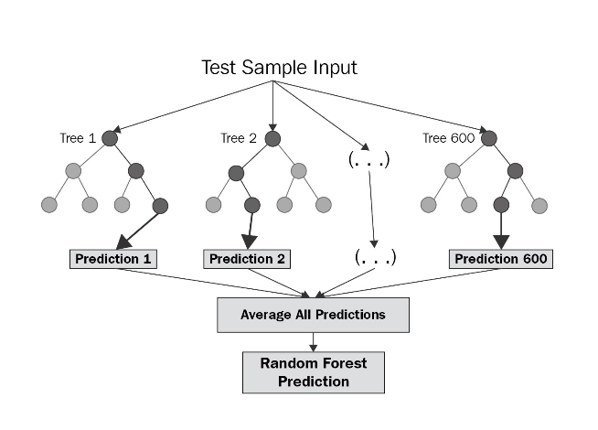It's a robust model that is widely used for preprocessing burden, handling missing values, and it's considering an excellent starting point. With this particular model hit a significant issue regarding time-series data, the model doesn't provide a good accuracy % and a high loss level. Random Forests don't fit very well for increasing or decreasing trends that are usually encountered when dealing with time-series analysis.

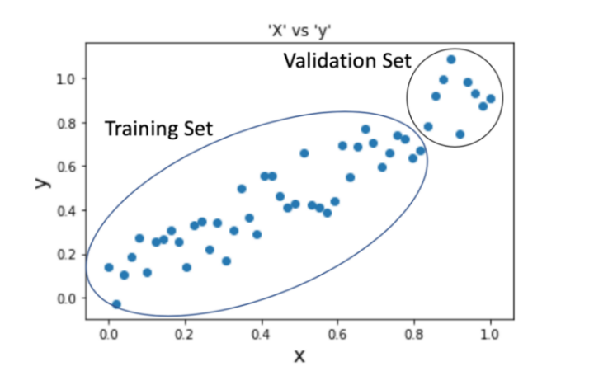Since a Random Forest constitutes of Decision Trees, that brings together data with similar categories, information with the intention of classifying it. When the model is evaluated with data that has not seen before, it tries to generate a prediction base on averages values from the training set. If the validation data contain data points that are greater or less than the training data points, the model will provide an average prediction since it is not able to extrapolate the growing / decreasing trend in our data.

**Why we went back to Neural Network**

With a Neural Network Model we are able to grab information and cluster large, raw data sets, and find patterns creating predictions. One of the benefitis of a Neural Network its is continue learning model as you can see below.

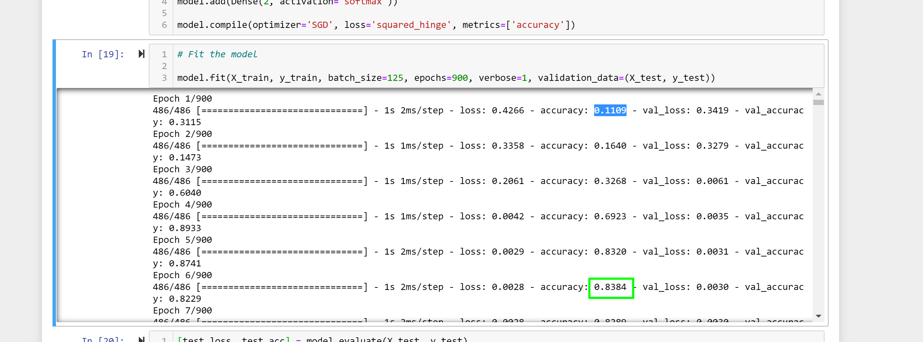

By Hypter Tunning this model by customizing the batch size and the number of Epoch we were able to obtain an accuracy of 95% and reduce loos to .2%



Using Neural Network Model for prediction with time series data is a good alternative, and we able to generate better predictions as you can see below.

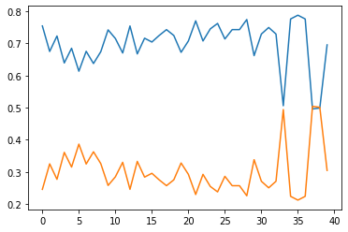

Prediction

**Setting Up the Neural Network Model**

1. Import the dataset

2. Split the data into features and labels, (X and y)

3. Split the data into training, test (80%, 20%)

4. The data set was not scale, we categorize the date using months since the model was not able to run using year / month / day

This adjustment of the data set improve the ML Model in terms of its ability to run as it is run.

Below you will see some pictures of the accuracy and loss without having the month categorize.

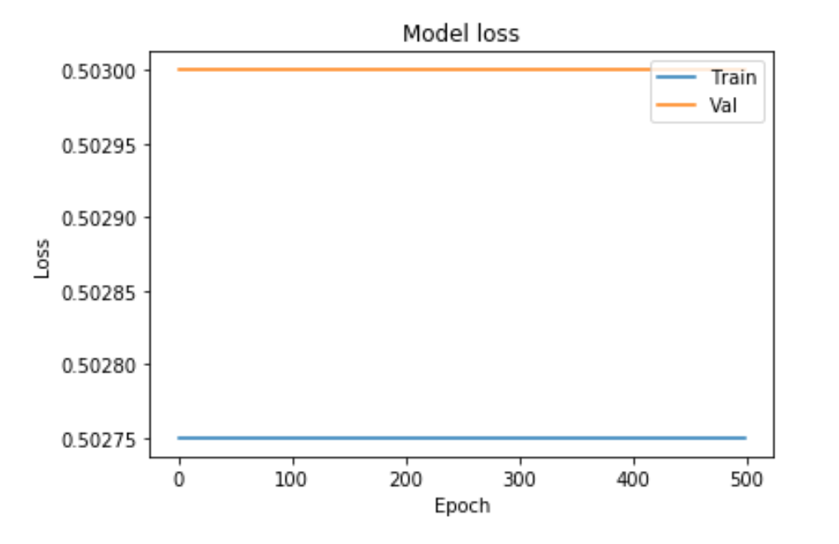

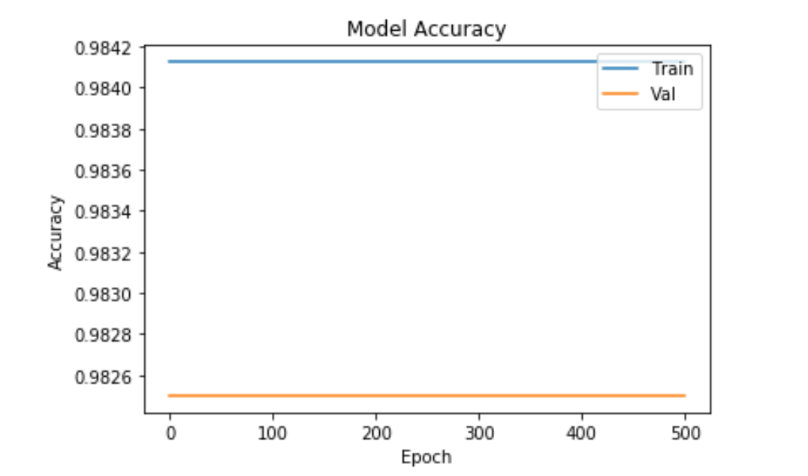

With data categorize the model was able to learn and improve its accuracy

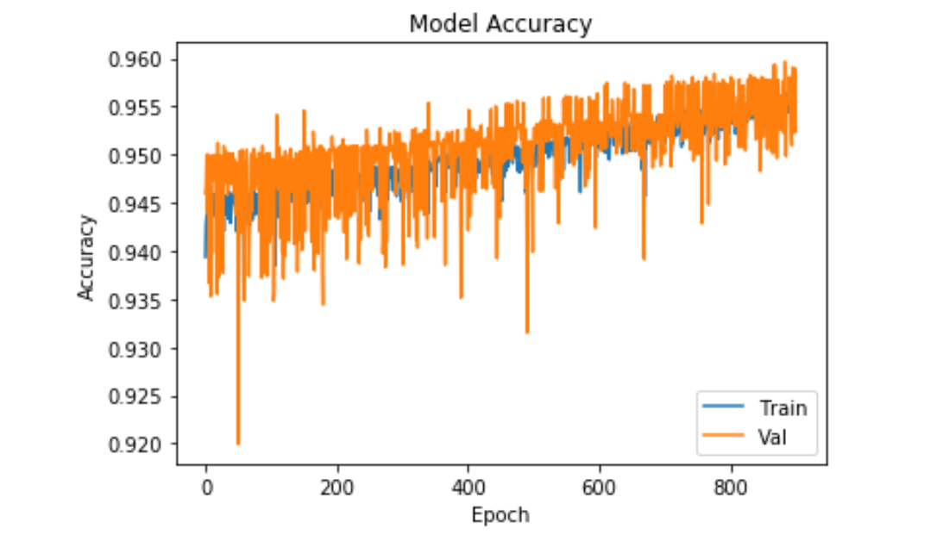

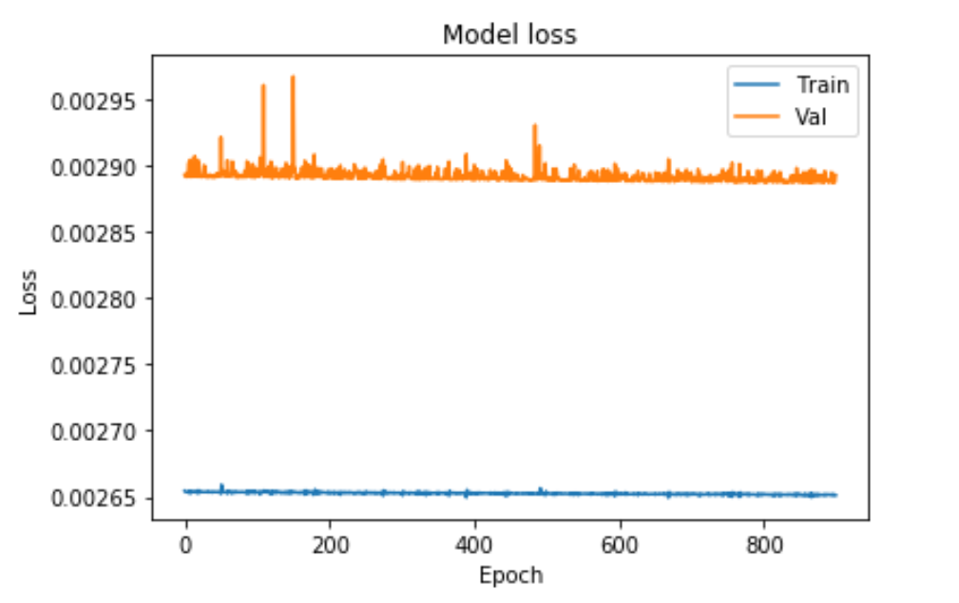

5. Sequential model in Keras

6. Define model - dense layers (neurons and activation - Rectified Linear Unit)

7. Compile and Fit model

**Setting Up the Model**

* Input Layer: 3 features (month, latitude, longitude)
* Hidden layer 1: 16 neurons, ReLu activation
* Hidden layer 2: 16 neurons, ReLu activation
* Hidden Layer 3: 2 neurones, Softmax activation
* Output Layer: 2 neuron, Sigmoid activation (squashing function limit the output to a range